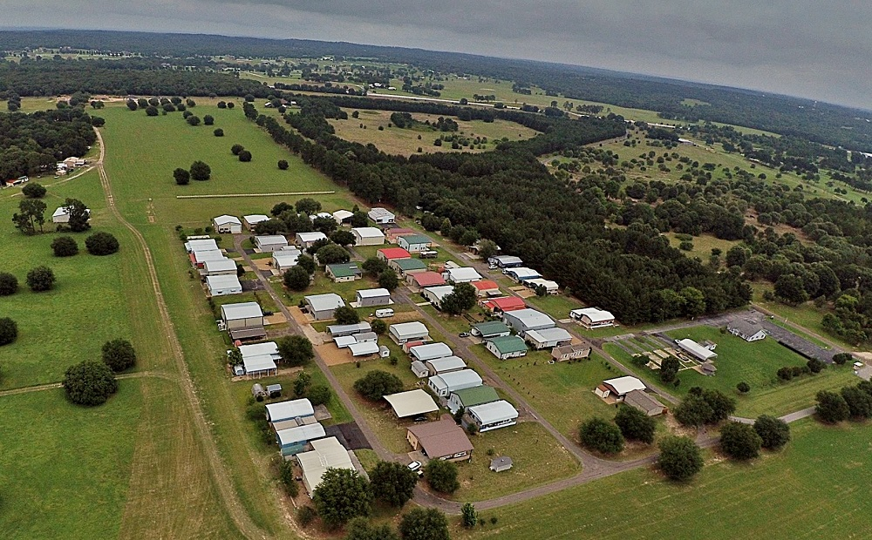

Bass Lake Christian Retirement Community

Lots and Homes For Sale

Revision September 4, 2020

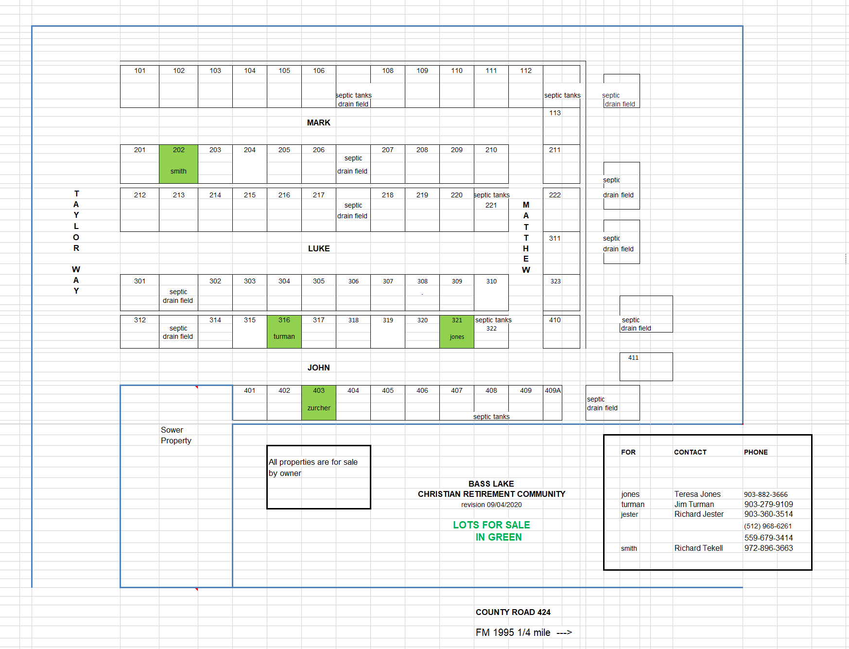

What is Bass Lake Christian Retirement Community (BLCRC) ?

Location of BLCRC
BLCRC is located in East Texas about half way between Van and Lindale, on County Road 424, off FM Road 1995. It is adjacent to the SOWER ministry office (see map).
BLCRC the organization/corporation

BLCRC is a unique Christian organization operated similar to a Homeowner’s Association (HOA) although it is not clearly defined as such. BLCRC is a member-controlled corporation, managed by a Board of Directors. The Board of Directors handles day to day matters, enforces all applicable rules (bylaws, city, county, state and federal laws) and
makes decisions on behalf of the corporation. There are a limited number of memberships available (64, based on the number of lots). BLCRC, and by extension, its members, have the responsibility to follow the rules and regulations put in place at all levels of the government. Much of this is reflected in BLCRC’s bylaws.

Board of Directors

The Board of Directors are elected from and by the membership at the Annual Meetings. They have the duty to act according to what is in the best interests of the corporation and its members. The Board of directors also has the task of making decisions when an event occurs which is not specifically addressed in the rules (bylaws and city, county, state and federal laws).
Members

Every member makes the choice to join BLCRC and in doing so, agrees to abide by its rules, both formal (bylaws, etc.) and informal (decisions by the Board of Directors). If the Board of Directors makes a decision which is unpopular, the members have the right to propose a change in the bylaws at the annual member’s meeting. Any member can propose a change in the bylaws and effect changes by member vote.

The State of Texas and BLCRC

The State of Texas recognizes BLCRC as the owner of the land and gives it (the corporation) rights as the owner. BLCRC gives its members some rights to the land. Members are given a lot to use within the limitations of the bylaws and building codes. Each lot has full RV hookups (50/30 amp electric, sewer, well water and city water). Annual dues of $800 (2020) pay for water, sewer, trash service and property taxes on the land. Members own the improvements (buildings) on the land and pay taxes accordingly. Members do not have the same rights or responsibilities as a typical deed holding homeowner because members do not own the land under which their homes, RV ports, etc. are situated. BLCRC owns the land. Members pay for the right to use it.

LOT 202

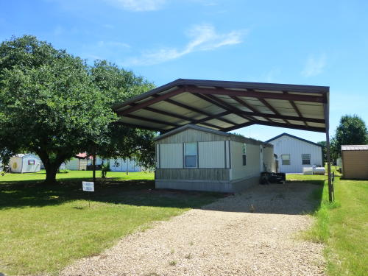

A handsome lot with a covered manufactured home. Trees to the North.

Contact 972-896-3663. 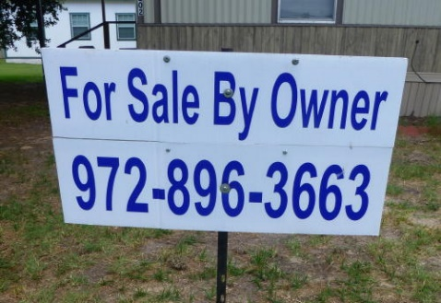

LOT 321

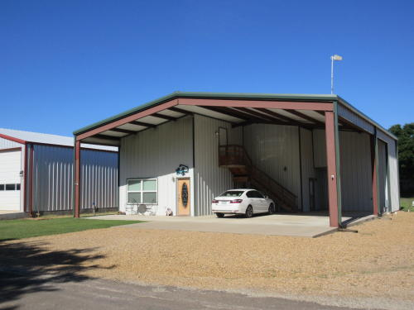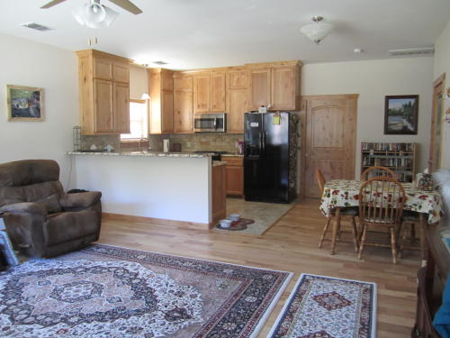

Excellent east Texas home base! Lot in Bass Lake Christian Retirement Community with 900 sq ft living space. Has separate 10 x 12 room for sewing, crafts, office, etc. Upstairs is open and currently has a workshop, an exercise area and storage. Completed July 2017. Features include: One bedroom. One bath. Walk-in shower. Hickory wood floors in living and dining area. Carpet in bedroom and closet. Tile flooring in kitchen, bath and entry ways. Knotty alder cabinets and wood trim throughout. Granite counter tops in kitchen with stainless steel sink. Knotty alder pocket doors. Large pantry. His and hers bathroom sinks. Built-in chest of drawers in closet. 9 foot ceilings with ceiling fans in living room and bedroom. Duel fuel stove (propane cook top with electric oven). Washer/dryer hookups. Cell phone signal booster. Metal roof and siding. Tankless water heater. Full hook-ups for RV, with 30 and 50 amp service. Heat pump with propane backup.
Pictures: https://www.dropbox.com/sh/8ij4l0fiol0th3s/AACvRLuOhrOB_slcjHHw8F1Ua?dl=0

$149,900 (Open to offers. Owner will not finance.)
Call or text: 903-882-3666. 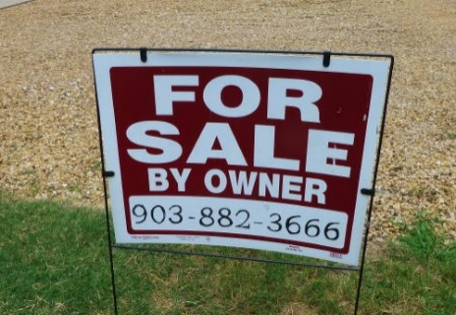

LOT 403

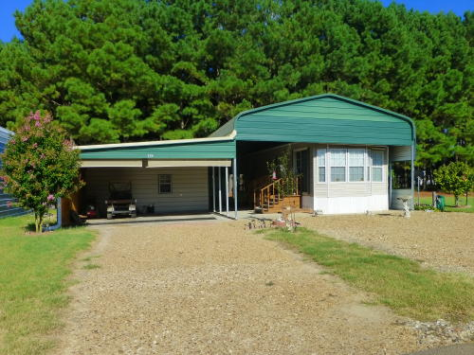

Lot with cover for RV or Park Model. Adjacent lot 402 also available.

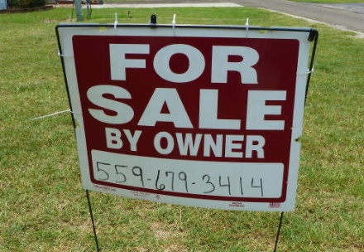

LOT 316

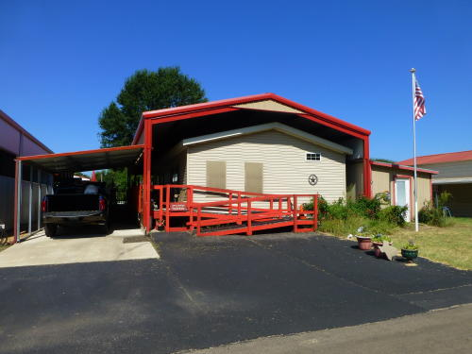
Lot with cover, manufactured home, and “man cave”

Contact Jim Turman, 9903-279-9109

The SOWER Office is adjacent to BLCRC
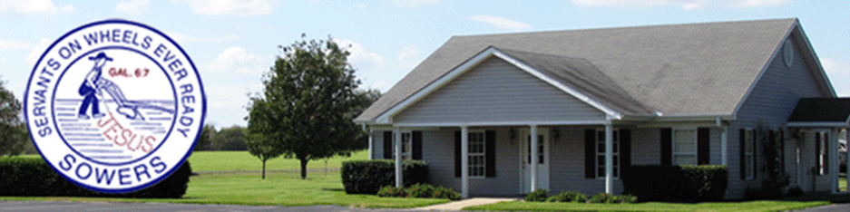
The SOWER office is on the southeast corner of the BLCRC property.
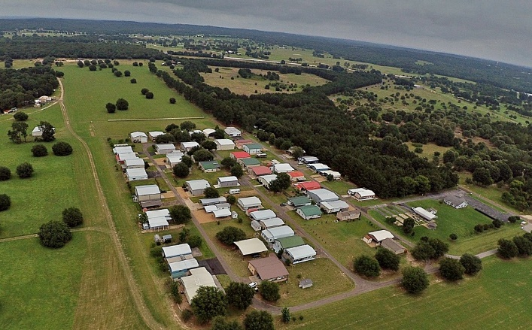 -- 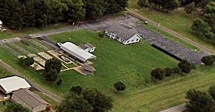

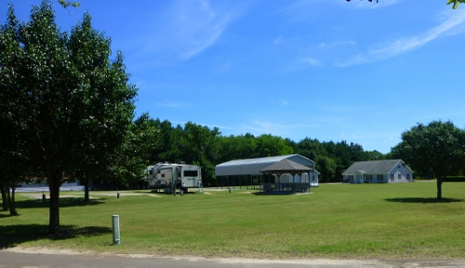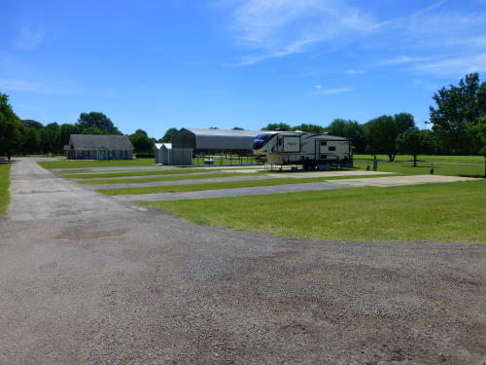

The Community Center at BLCRC
